**Integrating the Healthcare Enterprise**



**IHE Radiology**

**Technical Framework Supplement**

**Cross-Enterprise Read for Images**

**Workflow Definition Profile**

**(XRi-WD)**

**Volume 1**

**Draft in preparation for Public Comment**

<The IHE Documentation Specialist will change the title to just “Draft for Public Comment” upon publication for public comment; leave “as is” until then.>

Date: February 19, 2015

Author: Christopher Lindop

Email: [Radiology@ihe.net](mailto:Radiology@ihe.net)

**Foreword**

This is a supplement to the IHE Radiology Technical Framework Revision 13.0. Each supplement undergoes a process of public comment and trial implementation before being incorporated into the volumes of the Technical Frameworks.

This supplement will be published on May XX, 2015 for Public Comment. Comments are invited and may be submitted at [http://www.ihe.net/<domain>/<domain>comments.cfm](http://www.ihe.net/Technical_Framework/public_comment.cfm). In order to be considered in development of the Trial Implementation version of the supplement, comments must be received by <Month XX, 201X>.

This supplement describes changes to the existing technical framework documents.

“Boxed” instructions like the sample below indicate to the Volume Editor how to integrate the relevant section(s) into the relevant Technical Framework volume.

Amend section X.X by the following:

Where the amendment adds text, make the added text bold underline. Where the amendment removes text, make the removed text bold strikethrough. When entire new sections are added, introduce with editor’s instructions to “add new text” or similar, which for readability are not bolded or underlined.

General information about IHE can be found at: [www.ihe.net](http://www.ihe.net).

Information about the IHE Radiology domain can be found at: <http://www.ihe.net/Domains/index.cfm>.

Information about the organization of IHE Technical Frameworks and Supplements and the process used to create them can be found at: <http://www.ihe.net/About/process.cfm> and <http://www.ihe.net/profiles/index.cfm>.

The current version of the IHE Radiology Technical Framework can be found at: <http://www.ihe.net/Technical_Framework/index.cfm>.

# Introduction to this Supplement

This supplement is written according to the specific template defined for Workflow Definition profiles. The XRi-WD profile establishes a common set of rules to share between participants involved in a Cross-Enterprise Remote Read of Clinical Images workflow.

The Remote Read process, and workflow related to it, is applicable to many different sharing infrastructures. In this profile we present a specific XDS-I based use-case.

In Volume 1 we present the typical use-cases, describing many possible evolutions of the related workflow. We define the Workflow Participants involved and their ability within the workflow itself.

## Open Issues and Questions

1. The use case Remote Read with Direct Assignment presumes the Cross Enterprise Scheduler knows the availability of all Radiologists within the community to perform a Read. Is this feasible?
2. The use case Remote Read with Open Assignment presumes the Read Performer’s departmental information system is best to know the Radiologist availability to read. Is the process claim a read too burdensome?
3. The XDW profile specifies an XDS Document sharing model for managing workflow. For some, SOAP messaging is considered burdensome with too much overhead. An alternate method could be UPS-RS. With the primary goal, to provide workflow to an XDS-I environment, is there a compelling reason to specify the alternate method as the primary method? Could this be an option? Could this be a separate profile with MHD-I?

## Closed Issues

<List the closed issues/questions with their resolutions. These are particularly useful for recording the rationale for closed issues to forestall unnecessary rehashing in the future and/or to make it easier to identify when a closed issue should be re-opened due to new information.>

# Introduction

Integrating the Healthcare Enterprise (IHE) is an initiative promoting the use of standards to achieve interoperability of health information technology (HIT) systems and effective use of electronic health records (EHRs). IHE provides a forum for volunteer committees of care providers, HIT experts and other stakeholders in several clinical and operational domains to reach consensus on standards-based solutions to critical interoperability issues. IHE publishes the implementation guides they produce (called *IHE profiles*), first to gather public comment and then for trial implementation by HIT vendors and other system developers.

General information about IHE, including its governance structure, sponsorship, member organizations and work process, is available at [www.ihe.net](http://www.ihe.net/).

This pre-public comment document captures the intended use cases for the Cross-Enterprise Remote Read Workflow Definition Profile.

## Audience

The intended audience of this document is:

* Radiology staff and other clinical imaging specialist with Remote Read interests
* Technical staff of healthcare institutions with Remote Read interests
* Technical staff of healthcare image sharing service providers with Remote Read interests

## Relationship to Real-world Architectures

The IHE Actors and transactions described in the IHE Technical Framework are abstractions of the real-world healthcare information system environment. While some of the transactions are traditionally performed by specific product categories (e.g., HIS, Electronic Patient Record, RIS, PACS, Clinical Information Systems or imaging modalities), the IHE Technical Framework intentionally avoids associating functions or actors with such product categories. For each actor, the IHE Technical Framework defines only those functions associated with integrating information systems. The IHE definition of an actor should therefore not be taken as the complete definition of any product that might implement it, nor should the framework itself be taken to comprehensively describe the architecture of a healthcare information system.

The reason for defining actors and transactions is to provide a basis for defining the interactions among functional components of the healthcare information system environment. In situations where a single physical product implements multiple functions, only the interfaces between the product and external functions in the environment are considered to be significant by the IHE initiative. Therefore, the IHE initiative takes no position as to the relative merits of an integrated environment based on a single, all-encompassing information system versus one based on multiple systems that together achieve the same end.

Volume 1 – Profiles

# X Remote Read Workflow Definition Profile

Remote Reading workflow, also known as Tele-Radiology, is the practice of having medical images interpreted (read) by a reading specialist who is not present at the site the image study was acquired. This is particularly important for subspecialties like Nuclear Medicine or Neuro-radiology where these professionals are generally located at large institutions in major metropolitan areas, working daytime hours. Equally important are with smaller clinical institutions, including urgent care units, imaging centers, private practices and mobile imaging services with limited credentialed 24/7 staff to handle the read workload.

With the introduction of cross-enterprise image sharing profiles, such as XDS-I, providing cross-institutional access of the patient’s clinical images, the ability to share reading workload is the next logical step. Institutions today, share studies for better treatment of their patients. This image-sharing infrastructure is already producing improved patient care outcomes and reducing the need for duplicate procedures.

The goal of this profile is to improve the throughput and efficiencies of imaging centers and radiology departments, which acquire imaging studies, but lack the resources to efficiently read the images. Other facilities, which do have the necessary and available resources to include this work in their workload, are enabled by this profile to perform the read.

## X.1 Purpose and Scope

Cross-enterprise management of the workflow related to clinical processes is a fundamental topic with the increasing use by different sectors of document sharing related IHE profiles with their different types of document and information.

This profile is built upon the ITI XDW Profile to manage the Cross Enterprise Remote Read Workflow. The management of the workflow related to the Remote Read of Images is involved in many clinical and organizational processes for its important role in the process of digitalization.

The profile extends the use of Rad XDS-I beyond the sharing of images to the sharing of reading workload. In today’s limited environment, the lack of a workflow management, at the moment, narrows the clinical use to historical reference. No methods in XDS-I enable the reading management of the images in a cross-enterprise scenario. Without this workflow-sharing context, achieving workflow-sharing efficiencies is cumbersome and limited.

The creation of Remote Read Request by an Imaging department, opens a clinical process that involves many actors and that is a cross-enterprise workflow. The purpose of the XRi-WD profile is to precisely define the workflow associated with a Read Request and an acquired image study, the actors involved and the documents related with this process (produced in this or in other processes, but related to the Remote Read workflow).

## X.2 Remote Read Workflow Process Flow

A common workflow pathway that best illustrates the simplest process enabled by the XRi-WD where am Imaging Facility does not have Radiologists to read imaging studies after normal business hours. Within the health image share community, there are Reading Facility members, which have Radiologists available to perform the read.

The Cross-Enterprise Read for Images profile is modeled in tasks as represented in figure X.2-1 and outlined below:

1. Request Read: that tracks step A, performed by the Requester of the remote read
2. Assign Read: that tracks step B, C and D, where B & D are performed by the Cross-enterprise Scheduler and C is performed by the Read Performer
3. Perform Read: tracks to step E by the Read Performer
4. Receive Report: tracks to step F by the Read Requestor
5. ***Request Read*:**Gather the necessary clinical input information and submits a Read Request.

***Read Request -*** Contains the Read Request and the Image Manifest for the acquired study to be read. If there is additional relevant clinical information available, such as an Referral, relevant priors, laboratory reports, etc., these may be included.

1. ***Assign Read*:** Assigns Read Request to a Read Performer.

***Read Request Update:*** Contains the Read Request document updated with the assigned Remote Read Performer. Submission set includes the original documents from the Read Request.

1. ***Perform Read*:** Assigns read to Radiologist and performs the requested image read and creates the Image Report to be submitted back to the requester. . of the images and submits a Read Complete Submission Set. The Perform Read could include the creation of additional evidence documents, such as 3D reconstructed views, CAD reports, or even a preliminary Read. The sub-task workflow details are not part of this profile.

***Image Report - submission Set:*** Contains the Read Request document updated with the Reading Radiologist who performed the read. The Read Complete submission set includes the Final Report. If additional DICOM evidence documents were created as part of the Perform Read process step, an image manifest for the additional evidence documents is included.

1. ***Receive Image Report -Complete*:**  The Image Report – submission set is received and processed for completion. If evidence documents were created, the requesting site may require importing the evidence documents into their own system. The completion task may include report distribution to the referring physician. It may include services billing. The sub-task workflow details are not part of this profile.

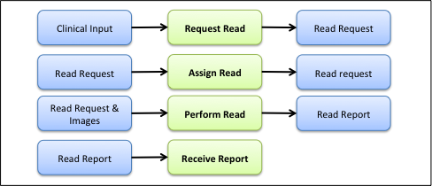

Figure X.2-1: Tasks involved in the Remote Read process

A complete process flow for the Remote Read Workflow Definition is shown in Figure X.2-2.

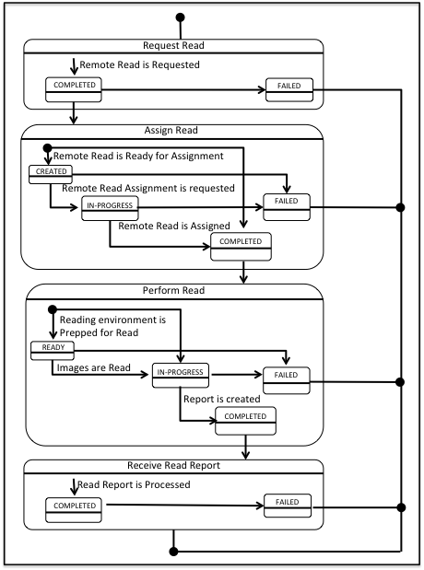

Figure X.1-2: Remote Read Workflow Definition complete process flow

The following table (table X.2-1) lists the various documents that shall, conditional, or may be referenced as either input or output documents for each task/status pair defined by the XRi-WD profile.

The values used in the Option column are defined as follows:

**R:** Required. Compliant source systems shall provide the document as referenced.

**C:** Conditional. Compliant source systems shall provide the document referenced if the document is available.

**O:** Optional. Compliant source systems may choose to provide the document reference.

**N/A:** Not Applicable.

|  |  |  |  |  |  |
| --- | --- | --- | --- | --- | --- |
| **Task** | **Task Status** | **Input Docs** | **Option** | **Output Docs** | **Option** |
| Request Read | COMPLETED | Relevant Clinical Documents | O | Read Request  Image Manifest  Relevant Clinical Documents | R  R  O |
| FAILED | N/A | - | Reason for Rejection | R |
| Assign Read | CREATED | Read Request  Image Manifest  Relevant Clinical Documents | R  R  O | N/A | - |
| IN-PROGRESS | N/A | - | N/A |  |
| COMPLETED | N/A | - | Read Request  Image Manifest  Relevant Clinical Documents | R  R  O |
| FAILED | N/A | - | Reason For Rejection | R |
| Perform Read | READY | Read Request  Image Manifest  Images  Relevant Clinical Documents | R  R  R  C | N/A | - |
| IN-PROGRESS | N/A | - | Preliminary Report  Evidence Documents | C  C |
| COMPLETED | N/A | - | Final Image Report  Evidence Documents | R  C |
| FAILED | N/A |  | Reason For Rejection | R |
| Receive Read Report | COMPLETED | Final Report  Evidence Documents | R  C | N/A | - |
| ABORT | N/A | - | Reason for Abort | R |

## X.3 Workflow Participants Actors and Process Flow

In this section we present the Workflow Participant Actors involved in the Remote Read process and, using the figure X.2-1, we describe in detail process transactions and interactions between them.

A Workflow Participant Actor is an abstraction of system along with users involved in the Remote Read process. They can be identified, based on their roles in the process, as one of four specific participants. Each of these workflow participants has specific rights and duties in the process. They drive the process from one step to another, performing determinate actions on the workflow.

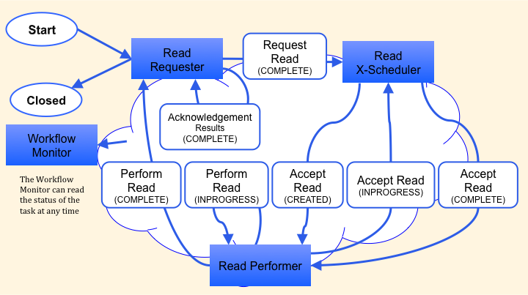

### X.3.1 Use Cases

This section describes the process flow and the associated clinical content of the Remote Read Workflow as it is defined in the IHE Technical Framework under “normal” circumstances. It covers the task state transitions, which reflect a typical remote read process from read request to perform read report received.

#### X.3.1.1 Use Case #1: Remote Read with Open Assignment

The Remote Read Request with Open Assignment pathway is the scenario where the ***Cross-Enterprise Read Scheduler Actor***, creates the read assignment, the ***Remote Read Performer Actor*** claims the assignment by changing the status to IN-PROGRESS. The ***Cross-Enterprise Read Scheduler Actor*** verifies the claims and COMPLETES the assignment task.

The following sequence of steps describes the typical process flow between the actors, the tasks and information flow specified by IHE.

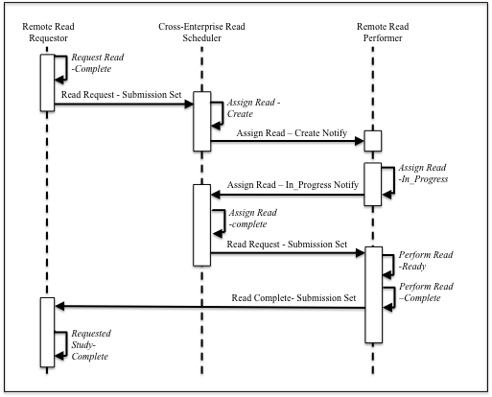

The process is initiated when a site has insufficient credentialed radiologists to read an acquired image study. The collaboration group as more than 1 Read Performer to assign the task to.

Process Flow:

1. ***Read Request-Complete*:**The Remote read Requestor gathers the necessary clinical information and submits a Remote Read Request Submission Set.

***Read Request - submission Set:*** Contains the Read Request document and the Image Manifest for the acquired study to be read. If there is additional relevant clinical information available, such as an Referral, relevant priors, laboratory reports, etc., these may be included.

1. ***Assign Read-Create*:** The Cross-Enterprise Read Scheduler receives the Remote Read Request Submission Set, creates the assign read task.

***Assign Read-Create Notify:*** Read Performer Actors who are included in the collaboration group, are notified of the created assign task.

1. ***Assign Read-In_Progress***: The Read Performer claims the Remote Read assignment and updates the Read Request with Read Performer Assignment.

***Read Request Update:*** The Read Request document updated with the claimed Remote Read Performer as assigned.

1. ***Assign Read-Complete***: The Cross-Enterprise Read Scheduler completes the Remote Read Performer assignment. This confirms the Read Performer’s claim for assignment.

***Read Request Update - submission Set:*** Contains the Read Request document updated with the confirmed assigned Remote Read Performer. The updated submission set includes the original documents from the Remote Read Requestor.

1. ***Perform Read-Ready***: The Remote Read Performer completes the preparation of the local environment for reading the remote images as necessary. The remote image study may be imported into the remote institutions equipment and a workitem placed on the remote Reading worklist. The sub-task workflow details are not part of this profile.
2. ***Perform Read-Complete*:** The Perform Read Performer completes the requested read of the images and submits a Read Complete Submission Set. The Perform Read could include the creation of additional evidence documents, such as 3D reconstructed views, CAD reports, or even a preliminary Read. The sub-task workflow details are not part of this profile.

***Image Report - submission Set:*** Contains the Read Request document updated with the Reading Radiologist who performed the read. The Read Complete submission set includes the Final Report. If additional DICOM evidence documents were created as part of the Perform Read process step, an image manifest for the additional evidence documents is included.

1. ***Receive Image Report -Complete*:**  The Image Report – submission set is received and processed for completion. If evidence documents were created, the requesting site may require importing the evidence documents into their own system. The completion task may include report distribution to the referring physician. It may include services billing. The sub-task workflow details are not part of this profile.

Post-condition:

Once the Requested study is completed, the Read Request Workflow process is closed.

#### X.3.1.2 Use Case #2: Remote Read with Direct Assignment

The Remote Read Request with Direct Assignment pathway is the scenario where the ***Cross-Enterprise Scheduler Actor****,* assigns the read assignment directly to the ***Read Performer Actor***.

The following sequence of steps describes the typical process flow between the actors, the tasks and information flow.

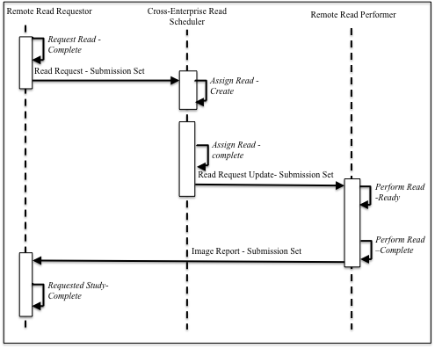

The process is initiated when a site has insufficient credentialed radiologists to read an acquired image study. The collaboration group has a single Read Performer to assign the task to. The process steps are the same as the Open Assignment with the following additional constraints.

Process Flow:

***Step 2:***  This task status updated may be skipped.

***Step 2a:*** Omit.

#### X.3.1.3 Use Case #3: Emergency Remote Read Request

The Emergency Remote Read Request pathway is the scenario where the Read Request has an Urgency code set to STAT. This could be an after hours trauma patient. The Imaging Facility has no credentialed readers available to perform the STAT read.

Note that the assigned Read Performer Performed Reader is expected to read the study with preliminary findings immediately after the images are available to read. A final report is still necessary and expected.

The Emergency Remote Read process steps are the same as either Remote Read with Direct Assign or Open Assign with the following additional constraints.

Step 1: The urgency code is set to STAT for the Read Request.

Step 2: The urgency code is set to STAT for the Assign Read – Create Notification.

Step 4: The Perform Read would include step 4.a following the Perform Read-Read and before the Perform Read-Complete.

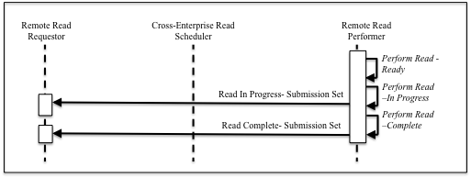

1. ***Perform Read-In Progress*:** The Perform Read Performer creates a preliminary findings report of the images and submits a Read In Progress Submission Set. The submission set could include the creation of additional evidence documents, such as 3D reconstructed views, CAD reports, or even a preliminary Read. The sub-task workflow details are not part of this profile.

***Read In Progress - submission Set:*** Contains the Read Request document updated with the Reading Radiologist who performed the preliminary read. The Read In Progress submission set includes the Preliminary Report. If additional DICOM evidence documents were created as part of this process step, an image manifest for the additional evidence documents is included.

Step 5: The Final Report replaces the Preliminary Report. The Final Report may be an Over Read of the Preliminary Report.

#### X.3.1.4 Use Case #4: Sub-Specialty Remote Read Request

The Sub-Specialty Remote Read Request pathway is the scenario where am imaging facility has a need to request a Sub-specialist to perform the read.

As an example, a community hospital has a NM Physician and a NM imaging system fully capable of acquiring SPECT Images, but lacks a credentialed NM Radiologist to read SPECT. Per the institutional business rules, all SPECT images require a NM credentialed Radiologist to perform the read.

The Emergency Remote Read process steps are the same as either Remote Read with Direct Assign or Open Assign with the following additional constraints.

Step 1: The intended recipient for the Read Request has the role set to NM Radiologist.

Step 2: The intended recipient for the Assign Read –Create Notification has the role set to NM Radiologist.

Step 3: The Read Request is assigned to a facility, which has credentialed NM Radiologist

Step 5: A credentialed NM Radiologist authors The Final Report.

#### X.3.1.5 Use Case #5: Double Remote Read Request

The Double Remote Read Request pathway is the scenario where am imaging facility has a need to request two reads on the same acquired image study.

As an example, the community hospital has acquired a Mammography study, which by local regulations, require a double read. Hence, per the institutional business rules, all Mammography images required to request a double remote read.

The Double Read process steps are the same as either Remote Read with Direct Assign or Open Assign with the following additional constraints.

Step 1: The Read Request type is Double Read.

Step 2: The Xscheduler initiates two Assign Read –Create tasks.

Step 5: The Remote Read performer may complete both Read Requests. However the Read Performer, in this case, must ensure that the same Radiologist does not complete both requests.

Step 6: The Requested Study Complete must receive the Image Report Submission Sets from both Readers prior to completion. Additionally, the Read Requester may have additional processes, including a creating a differential report. The additional processes are generally regional specific and the behavior is variable due to many factors including local regulatory mandates. Profiling the site-specific process beyond this step is left to the regional implementation.

#### X.3.1.6 Use Case #6: Remote Over Read Consult Request

The Remote Over Read Consult Request pathway is the scenario where am imaging facility has an imaging Report and needs to request an Over Read Consult.

This is often done for the purposes of quality assurance. Such as the Requesting physician has a Final Report but a particular study, but is concerned regarding the quality.

The Remote Over Read Consult Request process steps are the same as either Remote Read with Direct Assign or Open Assign with the following additional constraints.

Step 1: The Read Request type is Over Read Consult. The Final Report author is identified in the request to ensure that the original author does not select the workitem.

Step 4: The Read Performer must ensure that the author of the original report does not have access to this workitem.

Step 5: The over read consult physician either agrees or disagrees with the original report’s content. In the case of an agreement, an additional ‘Verifying Observer’ is added to the original report object. In the case of a disagreement, a discrepancy report is generated.

#### X.3.1.7 Use Case #7: Remote Peer Review Request

The Remote Peer Review Consult is identical to the Remote Over Read Consult Request pathway. The only difference is the initiating condition. The initiating condition for selecting the report to be reviewed is based on an internal algorithm of the Peer review requester.

The Remote Bind Peer Review Request is identical to the Remote Peer Review Request pathway. The only difference is the Step 1:

Step 1: The Read Request type is Blind Peer Review. The Final Report author is anonymized in the report for the review to be conducted blind. However the author is identified in the request to ensure that the original author does not select the workitem.

#### X.3.1.8 Use Case #8: Notifications for Task Status Updates

The following are requirements for the Remote Workflow actors to receive Notifications for Task Status Updates

***Read Requestor:***

The Read Requestor shall receive Notifications for all task status updates specified within this profile for the patients it submits a remote read request for.

***X-Scheduler:***

The X-Scheduler shall receive Notifications for Remote Read Request Complete, task status updates from any Read Requestor, which is a common member of a collaboration group.

The X-Scheduler shall receive Notifications for Assign Read InProgress, task status updates for from any Read Performer, which is a common member of a collaboration group.

The X-Scheduler shall receive Notifications for Requested Study Complete- Abort from any Read Requestor, while the Perform Read Task is active.

***Read Performer:***

The Read Performer shall receive Notifications for Assign Read Create, task status updates from any X-Scheduler, which is a common member of a collaboration group.

The read Performer shall receive Notifications for Requested Study Complete- Abort from any Read Requestor, while the Perform Read task is active.

***Remote Read Workflow Monitor:***

The Remote Read workflow Monitor shall receive Notifications for all task status updates, which is a common member of a collaboration group.

## X.4 Workflow Definition Actors and Options

Workflow Participants introduced in Section X.3 are expected to be supported by Workflow Definition Actors that represents abstractions of IT systems. Compliance to this workflow definition profile and its options are based on selecting the implementation of one or more of these Workflow Definition Actors.

### X.4.1 Workflow Definition Actors

Table X.4.1-1 specifies the mapping of Workflow Participants to Workflow Definition Actors.

**Table X.4.1-1: XRi-WD Workflow Participants grouping with Workflow Definition Actors**

| **Workflow Participant** | **Workflow Definition**  **Actor** |
| --- | --- |
| Read Requester | Read Requester Actor |
| Read Scheduler | Read Scheduler Actor |
| Read Performer | Read Performer Actor |
| Workflow Monitor | Workflow Monitor Actor |

### X.4.2 Workflow Options

Options that may be selected for this Profile are listed below along with the Workflow Definition Actors to which they apply. Although this Workflow Definition Profile is intended to be combined with other IHE Profiles, the specific options of these other Profiles are not addressed in this section, which focuses only on the Options identified for this Workflow Definition Profile.

Table X.4.2-1 specifies the options that are available, if any for each selected Workflow Actors.

Table X.4.2-1: XRi Profile Workflow Definition Actors and Options

| XRi-WD Workflow Definition Actor | option | Volume & Section |
| --- | --- | --- |
| Read Requester actor | *No options selected* | - |
| Read Scheduler actor | *No options selected* | - |
| Workflow Monitor actor | *No options selected* | - |

### X.4.3 Workflow Definition Profile Grouping with other Profiles

This Workflow Definition Profile is intended to be combined with other IHE Profiles. The profiles that are candidates for such combinations and the associated rules are specified in this Section.

Figure X.4.3-1 presents an overview for the major classes of IHE Profiles that shall or may be grouped:

* The Workflow Definition Profile SHALL be grouped with the XDW Profile.
* The Workflow Definition Profile SHOULD be grouped with one or more Document Content Profiles matched to the input and output reference “Document Labels” in the Workflow Definition Profile (Defined in Vol.2). The Workflow Definition Profile provides only “Document Labels” for these input and output reference documents and not the actual specifications. This selection of the actual document content specification (IHE Content profiles or others), need to be made by the environment that deploys the Workflow Definition Profile.
* The Cross-Enterprise Read for Images Workflow definition Profile is interoperable and shall be grouped with the Cross-Enterprise Document Sharing for Images (XDS-I). It is the intent to be interoperable with other Cross-Enterprise Image Sharing Profiles, such as XDR-I, XCA-I and MHD-I.
* The Cross-Enterprise Read for Images Workflow definition Profile is interoperable and shall be grouped with either the Document Metadata Subscription (DSUB) or XDR-I for the Open Assignment Notification and STAT Read Availability notification.
* The Cross-Enterprise Read for Images Workflow definition Profile is interoperable and should be grouped with the Multi-Patient Queries (MPQ) for the open assignment query transaction.

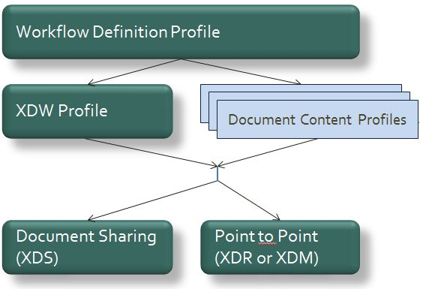

**Figure X.4.3-1: Grouping of profiles**

The grouping of XDW actors with each of the XRi-WD workflow definition actors is specified in table X.4.3-1. These XDW Actors support the creation, consumption and update of the XDW workflow document, which is the shared data structure which is tracking the evolution of the workflow. This allows the XRi-WD workflow definition actors, at any point in the workflow to access the most current status of the workflow and share the tasks performed with all other workflow definition actors.

Note: See IHE ITI TF-1: Section 30.3 (XDW Supplement) for other groupings that are needed for the XDW Actors to permit sharing of a Workflow Document with IHE XDS, XDR or XDM Profiles.

Table X.4.3-1: XRi-WD workflow definition actors grouping with XDW Profile Actors

Table X.4.3-1: XRi-WD Workflow Definition Actors grouping with XDW Actors

| Workflow Definition  Actor | Shall be grouped with: |
| --- | --- |
| Read Requester actor | XDW Content Creator  XDW Content Consumer  XDW Content Updater |
| Read Scheduler actor | XDW Content Updater  XDW Content Consumer |
| Read Performer actor | XDW Content Updater  XDW Content Consumer |
| Workflow Monitor actor | XDW Content Updater  XDW Content Consumer |

Table X.4.3-2: XRi-WD workflow definition actors grouping with XDS-I Profile Actors

Table X.4.3-2: XRi-WD Workflow Definition Actors grouping with XDS-I Actors

| Workflow Definition  Actor | Shall be grouped with: |
| --- | --- |
| Read Requester actor | XDS-I Image Document Source  XDS-I Image Document Consumer |
| Read Performer actor | XDS-I Image Document Source  XDS-I Image Document Consumer |

Table X.4.3-3: XRi-WD workflow definition actors grouping with DSUB Profile Actors for Notifications

Table X.4.3-3: XRi-WD Workflow Definition Actors, when grouping with DSUB Actors

| Workflow Definition  Actor | Shall be grouped with: |
| --- | --- |
| Read Requester actor |  |
| X-Scheduler actor |  |
| Read Performer actor |  |
| Workflow Monitor actor |  |

Table X.4.3-4: XRi-WD workflow definition actors grouping with XDR-I Profile Actors for Notifications.

Table X.4.3-4: XRi-WD Workflow Definition Actors, when grouping with XDR-I Actors

| Workflow Definition  Actor | Shall be grouped with: |
| --- | --- |
| Read Requester actor |  |
| X-Scheduler actor |  |
| Read Performer actor |  |
| Workflow Monitor actor |  |

Table X.4.3-4: XRi-WD workflow definition actors grouping with MPQ Profile Actors for Open Assign Query

Table X.4.3-4: XRi-WD Workflow Definition Actors, when grouping with MPQ Actors

| Workflow Definition  Actor | Shall be grouped with: |
| --- | --- |
| Read Requester actor |  |
| X-Scheduler actor |  |
| Read Performer actor |  |
| Workflow Monitor actor |  |

## X.5 XRi-WD Security Considerations

For this section please refer to the section ITI TF-1: 30.5.

## X.6 XRi-WD Cross Profile Considerations

### X.6.1 eReferral Workflow Definition

The eReferral Workflow Definition Profile should be considered for the patient-based image referral workflow as the initiating workflow. The XRi-WD profile augments the eReferal-WD when a cross-enterprise read is necessary to complete the eReferral workflow.

### X.6.2 Tumor Board Review Workflow Definition

The Tumor Board Workflow Definition Profile should be considered when the workflow includes a Tumor Board Review.

### X.6.3 XDS-MS Referral Content Profile

The XDS-MS Referal Content Profile should be considered, when available, for content input of the Remote Read submission set.